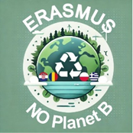

*Osnovna škola Antuna Kanižlića, Požega*

**3. Day of virtual activity in Požega, Croatia.**

**Material and accessories needed for activities:**

* Papers for each student
* Mobile phones or computers with internet access for research.
* Crayons or markers for each student

***Activity for students:***

1. **Fold the paper in half widthwise.**

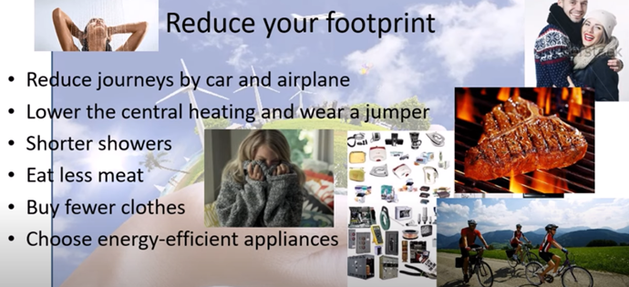

1. **Choose one of the offered topics:**
2. **Reduce your footprint through clothes you wear (sustainable fashion)**
3. **Reduce your footprint through food you consume**
4. **Reduce your footprint throught transport you use**
5. **Create a flyer using the given guidelines below.**

**Topic: Reduce your footprint through clothes you wear (sustainable fashion)**

1. **Leaflet page**

Show your topic with a drawing.

1. **Leaflet page (resources in clothing production)**

Remember what is needed from resources in the production of clothes, how much energy is used, chemicals, how much it costs to transport clothes to stores, marketing..., what is sustainable fashion.

**3. Leaflet page (statistical data)**

List statistical data (search for data for your country and other countries).

Who are the biggest consumers of clothes, who orders the most clothes online..., which countries or cities have the most second-hand stores…

1. **Leaflet page (reducing the ecological footprint)**

Write at least three or four ways that YOU can reduce the ecological footprint with the clothes you wear.

Write at least three or four ways that SOCIETY/state can influence the reduction of the ecological footprint through sustainable fashion.

Think of recycled materials, second-hand shops, applications...

**Topic: Reduce your footprint through food you consume**

**1. Leaflet page**

Show your topic with a drawing.

**2. Leaflet page (resources in food production)**

Take for example a hamburger from Burger King. Remember what is needed from resources in the production of buns in a hamburger, patty, mayonnaise, salad or cucumbers. How much energy was used, chemicals, how much it costs to transport food to Burger King, how much methane a cow produces, how much it costs and what food is needed to raise a cow...

1. **Leaflet page (statistical data)**

List statistical data (search for data for your country and other countries)

Who are the biggest importers of food, waste the most food... the biggest cattle breeders..., have the most fast food chains... which countries eat the most meat and meat products...

1. **Leaflet page (reducing the ecological footprint)**

Write at least three or four ways that **YOU** can reduce the ecological footprint of the food you eat or how you can reduce food waste.

Write at least three or four ways how **SOCIETY/state**, restaurants, can influence the reduction of the ecological footprint by encouraging ecological food production, how they can reduce food waste....

**Topic: Reduce your footprint through transport you use**

1. **Leaflet page**

Show your topic with a drawing.

1. **Leafet page (resources in transport;** **vehicles, roads)**

Remember what is needed from resources in the production of vehicles, construction of roads. What is needed to build roads (what happens to the habitat and living beings), how much and what energy is consumed for production and construction....

1. **Leafet page (statistical data)**

List statistical data (search for data for your country and other countries)

Who travels the most by plane, they have the most cars per capita, the most roads, which countries and cities have the worst air quality related to exhaust gases... which countries have the most electric cars...

1. **Leafet page (reducing the ecological footprint)**

Write at least three or four ways that YOU can reduce the ecological footprint through the transportation you use. Write at least three or four ways that SOCIETY/state can influence the reduction of ecological. Think of public transport, electric cars...